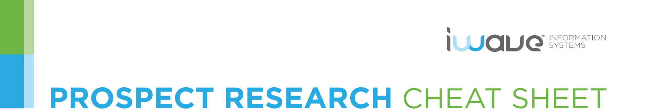

CASE STUDY
Making the Right ‘Ask’ With VeriGift’s Charitable Giving Data

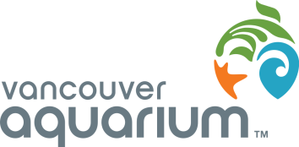
Background

The Vancouver Aquarium is a recognized leader in the conservation of aquatic life through display and interpretation, education, research, and direct action. The Aquarium is a self-supporting non-profit association and registered charity whose state-of-the-art facilities and programs attract more than one million visitors each year.
At a Glance:
Organization:
Vancouver Aquarium
Location:
Vancouver, BC

Industry:
Zoos & Parks, Environment, Conservation
Key Challenge:
Attract major gift donors with an affinity to the Aquarium to complete a major capital campaign.
Key Benefit:
VeriGift reveals past giving history with accurate records, providing critical insight for the fundraising team to make the right ask.

“VeriGift makes it easier to be sure we are asking the right questions to the right people. It’s about starting a conversation.”
Neil McEachern
Vancouver Aquarium
The Challenge
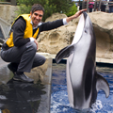
While the Vancouver Aquarium is a major attraction, encouraging and receiving support from the community can be difficult. “The perception is the Aquarium exists only for tourism,” said Neil McEachern, Development Coordinator, Prospect Research & Fulfillment. “But we do much, much more.” The Aquarium’s mandate includes animal welfare, marine research, education, and direct action conservation programs such as the Great Canadian Shoreline Cleanup. “We have a small team of fundraisers, and so finding donors with an affinity to the Aquarium’s various initiatives is one of the big things we focus on.” In the midst of a major capital campaign, Neil and his colleagues understand the importance of learning more about their donors in order to establish stronger relationships and make the right major gift ask.

The Solution
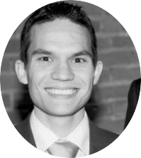
As the only researcher on staff, Neil uses a variety of free-to-access resources available through the local library. A few years ago, he also started to use the VeriGift charitable giving database to help with researching the Aquarium’s large donor pool. Neil uses VeriGift to learn more detailed information about a prospect’s connection to the Aquarium, and to learn about their past giving. “VeriGift has helped our fundraisers deepen relationships with donors and make the right ask,” said Neil. “It saves a lot of time, it’s straightforward to use, and it’s really great to be able to export everything in a separate file and prepare the data outside the tool.”
Neil highlighted the ability to select records and verify their primary source, such as an annual report. “It eliminates a lot of digging I have to do otherwise, so VeriGift has been really valuable to the team,” he added. Neil is confident the Aquarium’s capital campaign will be successful. “It’s about getting people excited about the organization and our mission.” When asked if VeriGift was helping the campaign, he said, “Definitely. It makes it easier to be sure we are asking the right questions to the right people. It’s about starting a conversation.”
